**DevOverFlow - An Advanced Q&A Platform with AI Integration**

*Submitted in partial fulfillment of the requirements for the degree of*

**Bachelor of Technology**

in

**Information Technology**

*by*

**ESHAN GUPTA**

**20BIT0262**

**Under the guidance of**

**Dr. Suganya P.**

**School of Computer Science Engineering and Information Systems (SCORE)**

**VIT, Vellore**



**May,2024**

**DECLARATION**

I hereby declare that the thesis entitled “**DevOverFlow - An Advanced Q&A Platform with AI Integration**” submitted by me, for the award of the degree of Bachelor of Technology in Information Technology to VIT is a record of bonafide work carried out by me under the supervision of Dr. Suganya P.

I further declare that the work reported in this thesis has not been submitted and will not be submitted, either in part or in full, for the award of any other degree or diploma in this institute or any other institute or university.

Place: Vellore

Date: 08.05.2024

**Signature of the Candidate**

**CERTIFICATE**

This is to certify that the thesis entitled “**DevOverFlow - An Advanced Q&A Platform with AI Integration**” submitted by Eshan Gupta & 20BIT0262, School of Computer Science Engineering and Information Systems (SCORE), VIT, for the award of the degree of Bachelor of Technology in Information Technology, is a record of bonafide work carried out by him / her under my supervision during the period, 02. 01. 2024 to 20.04.2024, as per the VIT code of academic and research ethics.

The contents of this report have not been submitted and will not be submitted either in part or in full, for the award of any other degree or diploma in this institute or any other institute or university. The thesis fulfils the requirements and regulations of the University and in my opinion meets the necessary standards for submission.

Place: Vellore

Date: 08.05.2024

**Signature of the Guide**

**Internal Examiner External Examiner**

Head of the Department

School of Computer Science Engineering and Information Systems (SCORE)

**ACKNOWLEDGEMENTS**

The opportunity VIT gave me to carry out my Capstone Project was an excellent learning and professional development opportunity. Thus, I am incredibly fortunate to have the chance to learn and grow and to utilize the skills I learnt during my degree to create this project.

I want to thank my professors, my guide for providing excellent advice and assistance. I owe them a debt of gratitude and would like to express my appreciation for their efforts.

This is a significant step forward in my professional development for me. In order to achieve my professional goals, I will work hard to put my newly acquired skills and knowledge to the greatest possible use, and I will continue to enhance them.

**Eshan Gupta**

**Executive Summary**

DevOverFlow is an ambitious capstone project that aims to create a sophisticated Question and Answer (Q&A) platform, integrating the functionalities of StackOverflow with innovative features. The key distinguishing factor is the implementation of AI-powered text generation, facilitated by OpenAI technology, to provide users with instant and accurate answers.

The project leverages cutting-edge technologies, including NextJS version 13.5 as the core framework, MongoDB as the database, and Tailwind CSS for the presentation layer. TypeScript is the language of choice, ensuring robust and maintainable code, with strategic use of React. The architecture is grounded in NextJS fundamentals, encompassing client-server dynamics, runtime versus build time considerations, and versatile rendering strategies like SSR, ISR, SSG, and CSR.

The platform promotes user-friendly interactions by allowing Markdown input for questions and ensuring full responsiveness across diverse devices. Users can pose questions, receiving AI-generated answers alongside community responses. Active participation earns users' badges and reputation points, contributing to an incentivized and dynamic knowledge-sharing ecosystem. DevOverFlow aims to redefine Q&A platforms by combining AI innovation with a rich feature set for an unparalleled user experience.

The project's key objectives include implementing AI-powered text generation, creating a user-friendly interface, developing a comprehensive authentication system, designing a scalable backend architecture, and enhancing user experience through responsive design and interactive features. The proposed architecture consists of a frontend layer, backend infrastructure, AI-powered text generation, a recommendation system, authentication and access control, and responsive design with performance optimization.

**Contents**

|  |  |  |  |
| --- | --- | --- | --- |
| **S.No.** | **Title** | | **Page No.** |
|  | Acknowledgement | | 4 |
|  | Executive Summary | | 5 |
|  | Table of Contents | | 6 |
|  | List of Figures | | 7 |
|  | List of Tables | | 8 |
|  | Abbreviations | | 9 |
| 1. | Introduction | | 10 |
|  | 1.1 | Objective | 10 |
|  | 1.2 | Motivation | 10 |
|  | 1.3 | Background | 11 |
| 2. | Project Description and Goals | | 11,12 |
| 3. | Technical Specification | | 12,13 |
| 4. | Design Approach and Details | | 14 |
|  | 4.1 | Design Approach/Materials and Methods | 14 |
|  | 4.2 | Codes and Standards | 14 |
|  | 4.3 | Constraints, Alternatives and Tradeoffs | 14 |
| 5. | Schedule, Tasks and Milestones | | 15-17 |
| 6. | Project Demonstration | | 18-27 |
| 7. | Cost Analysis/ Result and Discussion | | 28,29 |
| 8. | Summary | | 30 |
| 9. | References | | 31,32 |
|  | Appendix A | | 33,34 |

**LIST OF FIGURES**

|  |  |  |
| --- | --- | --- |
| S. No. | Title | Page No. |
| 6.1 | Project Directory | 18 |
| 6.2 | Architecture Diagram | 20 |
| 6.3 | Home Page | 21 |
| 6.4 | Auth Page | 21 |
| 6.5 | View Question/ Answer Question Page | 22 |
| 6.6 | Community Page | 22 |
| 6.7 | Collections Page | 23 |
| 6.8 | Jobs Page | 23 |
| 6.9 | Tabs Page | 24 |
| 6.10 | Ask a question Page | 24 |
| 6.11 | Profile Page | 25 |
| 6.12 | Edit Profile Page | 25 |
| 7.1 | Performance Metrics | 29 |

**LIST OF TABLES**

|  |  |  |
| --- | --- | --- |
| S. No. | Title | Page No. |
| 5.1 | Tasks / Review Schedule | 15 |
| 5.2 | Project Diary | 16 |
| 6.1 | User Schema | 26 |
| 6.2 | Question Schema | 26 |
| 6.3 | Tags Schema | 26 |
| 6.4 | Answer Schema | 27 |
| 6.5 | Interaction Schema | 27 |

**ABBREVIATIONS**

1. Q&A - Question and Answer

2. NLP - Natural Language Processing

3. SSR - Server-Side Rendering

4. ISR - Incremental Static Regeneration

5. SSG - Static Site Generation

6. CSR - Client-Side Rendering

7. API - Application Programming Interface

8. JSON - JavaScript Object Notation

9. BSON - Binary JSON

10. RDBMS - Relational Database Management System

11. HTML - Hypertext Markup Language

12. SIASN - State Civil Apparatus Information System

13. FCP - First Contentful Paint

14. LCP - Largest Contentful Paint

15. TTI - Time to Interactive

16. TBT - Total Blocking Time

17. SEO - Search Engine Optimization

1. **Introduction**

DevOverFlow is a novel Question and Answer (Q&A) platform designed to rival established platforms like StackOverflow. It leverages cutting-edge technologies including NextJS 13.5, MongoDB, Tailwind CSS, and TypeScript to deliver an exceptional user experience. A key differentiator is the integration of OpenAI's AI-powered text generation, providing instant and accurate answers alongside community-driven responses. The platform boasts a comprehensive feature set including user authentication, robust search, a reputation system, and Markdown support for questions. DevOverFlow aspires to redefine Q&A platforms by fostering a dynamic knowledge-sharing environment through the power of AI and a rich feature set.

* 1. **Objective**

The primary objective of the DevOverFlow project is to address the shortcomings of existing Q&A platforms by leveraging advanced technologies to deliver instant and accurate answers to user queries. The project specifically focuses on integrating AI-powered text generation capabilities, provided by OpenAI technology, into a Q&A platform inspired by the functionalities of StackOverflow. This approach seeks to enhance the responsiveness and effectiveness of the platform, providing users with a more engaging and efficient knowledge-sharing experience.

**1.2 Motivation**

The document delves into the rich landscape of research and development efforts surrounding Q&A platforms, highlighting the drive to improve user engagement, content relevance, and system efficiency. The motivation behind DevOverFlow is rooted in these evolving needs, with a particular emphasis on exploring the integration of artificial intelligence (AI) and natural language processing (NLP) techniques to facilitate automatic response generation. Additionally, the project is inspired by the growing interest in AI-powered recommendation systems that suggest relevant questions, answers, and resources based on user preferences and browsing history.

**1.3 Background**

The background context for the DevOverFlow project underscores the significance of robust authentication systems, scalable architectures, and responsive designs to ensure seamless user interactions across diverse devices. The document also acknowledges the advancements in backend technologies, such as server-side rendering (SSR), incremental static regeneration (ISR), and client-side rendering (CSR), which have contributed to improved performance, scalability, and user experience. Furthermore, the project's development is influenced by the growing popularity of TypeScript and React in web development, as these technologies enable code maintainability, type safety, and component reusability.

1. **Project Description and Goals**

The DevOverFlow project is an ambitious undertaking that aims to create a sophisticated Question and Answer (Q&A) platform, integrating the functionalities of StackOverflow with innovative features. The primary distinguishing factor lies in the implementation of AI-powered text generation, facilitated by OpenAI technology, to provide users with instant and accurate answers.

The key objectives of the DevOverFlow project include:

**1. Creating a user-friendly interface:** The project places a strong emphasis on developing a user-friendly interface for posing questions and accessing responses. This focus on user experience is intended to foster community engagement and facilitate seamless knowledge sharing among users.

**2. Developing a comprehensive authentication system:** The project aims to implement a robust authentication system to manage user accounts, permissions, and access control effectively. This will ensure secure interactions and protect user data from unauthorized access.

**3. Designing a scalable backend architecture:** The project leverages the capabilities of NextJS and MongoDB to create a scalable backend infrastructure that can handle the demands of a thriving Q&A platform. This approach is designed to ensure optimal performance, reliability, and data integrity.

**4. Implementing an AI-powered text generation system:** The project seeks to integrate advanced AI and natural language processing (NLP) capabilities to generate instant and accurate responses to user queries using Open-AI API. This feature is designed to enhance the responsiveness and effectiveness of the Q&A platform, setting it apart from traditional Q&A platforms.

**5. Enhancing user experience through responsive design and interactive features:** The project prioritizes responsive design to ensure seamless access across diverse devices. Additionally, it incorporates interactive features, such as upvoting and downvoting questions and answers, saving questions for future reference, following tags, badges, and reputation points, to create an engaging and dynamic knowledge-sharing ecosystem.

By addressing the shortcomings of existing Q&A platforms and integrating cutting-edge technologies, the DevOverFlow project aspires to redefine the Q&A landscape, providing users with an unparalleled experience that combines AI innovation with a rich feature set.

1. **Technical Specification**

The DevOverFlow project adopts a robust technical architecture built on NextJS version 13.5, MongoDB, and other cutting-edge technologies to ensure scalability, performance, and maintainability. The technical specification of the project can be broken down into the following key components:

1. Frontend Layer:

The presentation layer of the DevOverFlow platform is developed using NextJS, incorporating React components to create dynamic user interfaces. Tailwind CSS is utilized for responsive styling, ensuring an optimal user experience across diverse devices. This frontend layer is designed to provide a seamless and visually appealing interface for users to interact with the Q&A platform.

1. Backend Infrastructure:

The backend of the DevOverFlow project consists of API routes, server-side form validation, and authentication mechanisms, all implemented using the NextJS framework. MongoDB serves as the database management system, facilitating efficient data storage, retrieval, and manipulation. This backend infrastructure is responsible for handling the core functionalities and data management of the Q&A platform.

1. AI-Powered Text Generation:

A key aspect of the DevOverFlow project is the integration of OpenAI API technology to generate instant and accurate answers to user queries. The platform employs natural language processing (NLP) techniques to analyse and interpret user input, generating relevant responses in real-time.

1. Recommendation System:

The DevOverFlow project incorporates a robust recommendation system that utilizes classic algorithms to suggest relevant questions, answers, and resources based on user preferences and browsing history. This feature is designed to enhance the user experience by surfacing content that is tailored to the individual's interests and needs.

1. Authentication and Access Control:

The DevOverFlow project features a comprehensive authentication system that manages user accounts, permissions, and access control. This system ensures secure interactions and protects user data from unauthorized access. The project utilizes the Clerk authentication service to establish the authentication system, and user data is stored in the MongoDB database to maintain data privacy.

1. Responsive Design and Performance Optimization:

The DevOverFlow platform is designed to be fully responsive, adapting seamlessly to various screen sizes and resolutions. To optimize performance and minimize latency, the project employs strategies such as server-side rendering (SSR), incremental static regeneration (ISR), and client-side rendering (CSR).

1. **Design Approach and Details**

**Figma Link-:** [**Link**](https://www.figma.com/file/2vtjgodtBxTdg0zOUHPvXh/JSM-Pro---DevOverflow?type=design&node-id=1-49&mode=design) **Prototype Link**-: [**Link**](https://www.figma.com/proto/2vtjgodtBxTdg0zOUHPvXh/JSM-Pro---DevOverflow?node-id=1-31&scaling=min-zoom&page-id=0%3A1&t=JOGVoQI0uV9Rwuda-1)

The DevOverFlow project has been designed with a strong focus on creating an intuitive and visually appealing user interface. The design of the platform has been entirely conceived in Figma, a leading UI/UX design tool, ensuring a cohesive and polished aesthetic across all the key modules and functionalities with utmost responsivity across all the available screen sizes.

**4.1 Design Approach/Materials and Methods**

The design approach for DevOverFlow has been centred around delivering a user experience that is both visually engaging and highly responsive. The platform is available in both light and dark themes, catering to the preferences of a diverse user base. I have meticulously crafted each element, to create a visually harmonious and accessible interface. The use of Figma as the primary design tool has enabled me to iterate quickly, and ensure pixel-perfect implementation.

**4.2 Codes and Standards**

The DevOverFlow project adheres to industry-standard coding practices and design guidelines to ensure the highest levels of quality and maintainability. The frontend codebase follows the best practices of the React, NextJS ecosystem, leveraging the robust features of the NextJS framework. The backend development adheres to established API design principles and embraces modular, scalable architecture. Throughout the development process, the I have been vigilant in upholding accessibility standards and web content guidelines to make the platform inclusive and user-friendly.

**4.3 Constraints, Alternatives and Trade-offs**

In the course of designing and developing DevOverFlow, I have navigated various constraints, considered alternative approaches, and carefully evaluated trade-offs. The need to balance cutting-edge features with a streamlined user experience has been a constant challenge. Similarly, I had to make decisions around the optimal balance between server-side and client-side rendering to maximize performance across diverse device capabilities and network conditions. The integration of AI-powered text generation has also introduced unique design considerations. The alternatives for this particular website currently in the market is StackOverflow.

1. **Schedule, Tasks and Milestones**

|  |  |  |  |
| --- | --- | --- | --- |
| **Review Number** | **Date and Time** | **Work Presented on the review** | **Targets till next review** |
| Review 0 | 11.01.2024, 2:00 P.M. | Overview and objective of the project and Idea. | Completing the Figma Design and initial documentation like problem definition and literature review. |
| Review 1 | 15.02.2024, 1:00 P.M. | Presented the Figma design of the website with problem definition, literature review, proposed architecture and objectives. | Start the implementation of the project and complete 70% of the project by next review. Suggestions regarding Generate AI Answer feature and recommendation algo. |
| Review 2 | 05.04.2024, 7:00 P.M. | 70% implementation including major features like local search, auth, posting a question, posting an answer, community, collections, profile and tags page was ready. | Features to be completed by the final review-:   * Pagination * Generate AI Answer * Global Search * Jobs Page * Recommendation algo |
| Review 3 | 22.04.2024 | 100% project with complete documentation is ready. | Tips for presentation during the final review and some minor changes. |
| Final Review | 08.05.2024 | Final Presentation of the project. | NA |

* **Project Diary**

|  |  |  |  |  |
| --- | --- | --- | --- | --- |
| **S.No.** | **Date** | **Key Points** | **Remark by Guide** | **Guide Name** |
| 1 | 06-01-2024 | About Project Topic | Title discussion | Dr. Suganya P |
| 2 | 14-01-2024 | Abstract and Objective |  | Dr. Suganya P |
| 3 | 18-01-2024 | Literature Survey | Suggested for 10 Papers | Dr. Suganya P |
| 4 | 20-01-2024 | Doubts |  | Dr. Suganya P |
| 5 | 30-01-2024 | Architecture |  | Dr. Suganya P |
| 6 | 08-02-2024 | Discuss about review 1 and PPT |  | Dr. Suganya P |
| 7 | 20-02-2024 | Discuss about Auth / Home-Page Features | Suggested some features like views | Dr. Suganya P |
| 8 | 28-02-2024 | Discuss about backend implementations | Suggested some secure methods for backend | Dr. Suganya P |
| 9 | 07-03-2024 | Discuss for implement functionalities on ask a question page |  | Dr. Suganya P |
| 10 | 14-03-2024 | Trends for the website |  | Dr. Suganya P |
| 11 | 21-03-2024 | Community Page features | Suggested features for filters | Dr. Suganya P |
| 12 | 28-03-2024 | Discussion on other pages |  | Dr. Suganya P |
| 13 | 02-04-2024 | Discuss about review 2 and PPT |  | Dr. Suganya P |
| 14 | 08-04-2024 | Pagination Feature implemented | Suggested recommendation algo idea | Dr. Suganya P |
| 15 | 12-04-2024 | Global Seach and Recommendation Algo implemented |  | Dr. Suganya P |
| 16 | 16-04-2024 | Jobs Page and Generate AI Answer feature Implemented | Documentation doubts for final review were cleared | Dr. Suganya P |
| 17 | 20-04-2024 | 100% implementation of the project completed | Documentation finalization. | Dr. Suganya P |

* **Milestones**
  1. ­Completed Project Ideation and proposal finalization – Review 0
  2. Completed abstract and problem definition – Review 0
  3. Completed Literature Survey and defined project objectives- Review 0
  4. Finalized project architecture, system design and UI design – Review 1
  5. Development environment setup and initial coding – After Review 1
  6. Implemented Auth using Clerk and theme switching – Review 2
  7. Implemented 70% of the website, features such as Home Page, Community, Collections, Tags and Ask a question Page – Review 2
  8. Functionalities like upvoting, downvoting, answering a question, Filtering and local search were implemented – Review 2
  9. Website Responsivity was also implemented – Review 2
  10. Performed Testing on lighthouse and found fantastic scores (Performance – 86, Accessibility – 94, Best Practices – 100, SEO – 100) – Review 2
  11. Implemented features such as Generate AI Answer, Recommendation Algo, Pagination (Remaining 30%) – Review 3
  12. Jobs Page was also implemented as everything was on time using Rapid API – Review 3
  13. Conducted thorough testing and achieved excellent Lighthouse scores – Review 3
  14. Deployed the final web application – Review 3
  15. Completed the final documentation – Review 3
  16. Project presentation and final demonstration – Final Review

1. **Project Demonstration**

**GitHub Link-:** [**Link**](https://github.com/eshan1925/stackoverflow_nextjs13) **Deployed Site Link-:** [**Link**](https://devoverflow-eshan.vercel.app/)

This project is built with a modern tech stack, utilizing the following technologies:

* **Next.js:** A React framework for server-rendered and statically generated web applications, offering optimal performance and SEO benefits.
* **Tailwind CSS:** A utility-first CSS framework that provides a rapid and responsive approach to styling, allowing for quick customization and design iteration.
* **MongoDB:** A flexible NoSQL database well-suited for storing and managing various data structures, perfect for this project's needs.
* **Clerk:** A user authentication service that simplifies user management and secure login functionalities, ensuring a smooth user experience.
* **OpenAI Api:** Publicly available code interfaces that allow applications to interact and share data seamlessly. Used for generate AI Answer feature in the website.
* **Rapid API:** Rapid API is a large online marketplace where developers can discover and connect to a vast collection of APIs (Application Programming Interfaces) to enhance their projects. I have used this for building up the jobs page.
* Various other libraries like Shadcn, Tiny mce editor and html React parser have been used.

Now coming to the implementation of the website so here is the entire project structure of the website-:

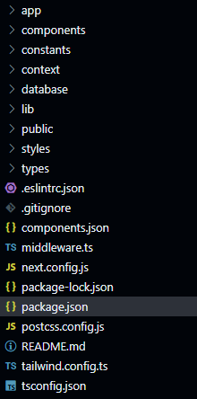

Fig 6.1 – Project Directory

Here's an explanation of each folder and file in the Next.js project directory provided, based on the image:

**Folders**

* **app:** Contains the core application components and logic and based on the folder name the Next-Js routing takes place.
* **components:** This houses all the reusable React components for building the UI.
* **constants:** Likely stores fixed values or configurations used throughout the application.
* **context:** It contain Theme providers for managing application state.
* **database:** It contains code for interacting with the MongoDB database.
* **lib:** It contains helper functions or utility code and general action functions used across the project.
* **public:** It stores static assets that can be directly accessed in the browser, such as images, fonts, or stylesheets.
* **styles:** It contains global or project-wide CSS styles.
* **types:** It contain TypeScript type definitions for improved code structure and type safety.

**Files**

* **.eslintrc.json:** It holds configurations for ESLint, a static code analysis tool.
* **.gitignore:** It specifies files or patterns to be ignored by Git version control.
* **components.json:** It consists of the folder routes and details for shadcn library.
* **middleware.ts:** It contains middleware functions for specifying the public and private routes for Clerk Auth.
* **next.config.js:** Configures the Next.js application's behavior.
* **package-lock.json:** It is generated by npm and lists the exact package versions required by your project.
* **package.json:** It specifies the project's dependencies and configurations.
* **postcss.config.js:** It has configurations for PostCSS, a tool for processing CSS.
* **README.md:** It contains project documentation or instructions for setup.
* **tailwind.config.ts:** Configuration file for Tailwind CSS.
* **tsconfig.json:** Configuration file for TypeScript, a superset of JavaScript that adds optional static typing.

Now let’s talk about the project architecture-:

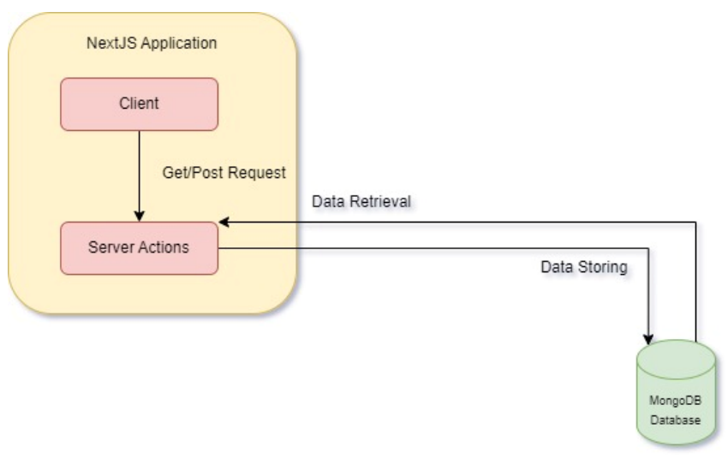

Fig 6.2 Architecture Diagram

The figure depicts a client-server system with Next.js serving as the client-side framework. Here’s a breakdown:

* **Client-side (Next.js application):** This initiates data requests and displays retrieved information. It utilizes Get/Post requests to interact with the server.
* **Server-side:** Handles data retrieval and storage. It fulfills client requests and communicates with the MongoDB database.
* **Data Storage (MongoDB database):** Stores the application’s data. The server retrieves and stores data from this database.

In essence, this architecture separates the user interface (client-side) from the data logic and storage (server-side). This promotes better organization and maintainability.

Now let’s talk about each and every page of the project and how it looks on the website-:

1. Home Page

This page is the landing page of the website and consists of 3 main sections-:

1. Left Side Bar-: This is from where the user can navigate to different sections of the website.
2. All Questions Section-: All the questions are displayed here and a user can search for the questions, apply filter, ask a new question and view and answer the questions.
3. Right Side Bar-: This page consists of Top Questions and popular tags on the website.

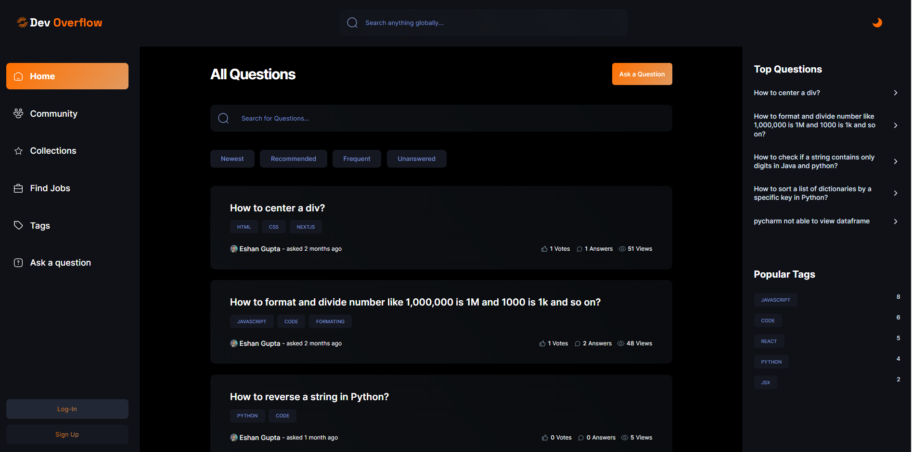

Fig 6.3 Home Page

[2] Auth Page

This page is used for authentication i.e., login and signup page. It is powered by clerk. User can create an account and can login using GitHub and Google.

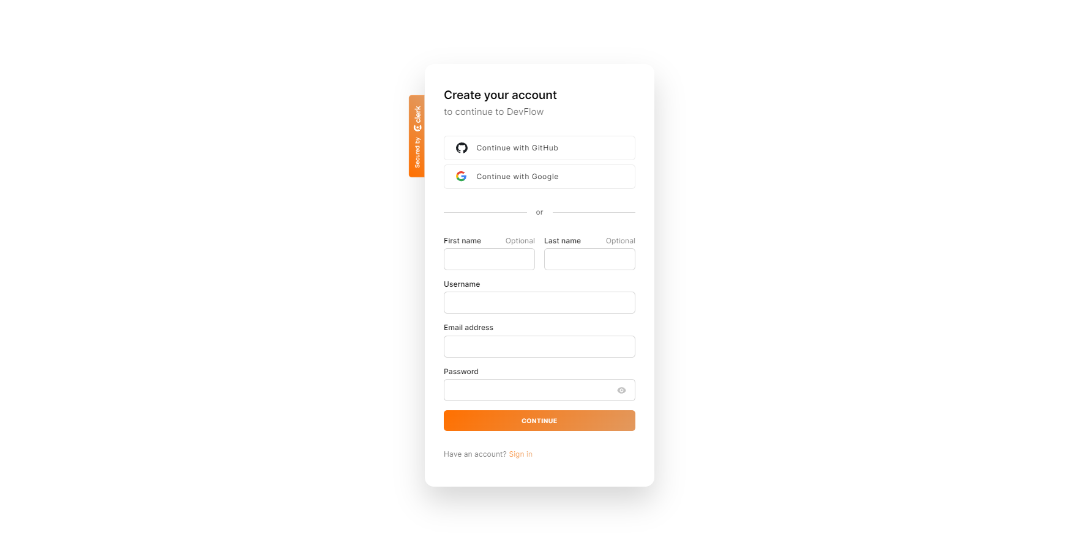

Fig 6.4 Auth Page

[3] View Question Page and Answer the question Page

This page is the view a question page, under this page a user can view answers and question details, can give new answers using the Generate AI Answer button. User can also upvote or downvote a question and an answer. With this user is also given an option to save a question for future use.

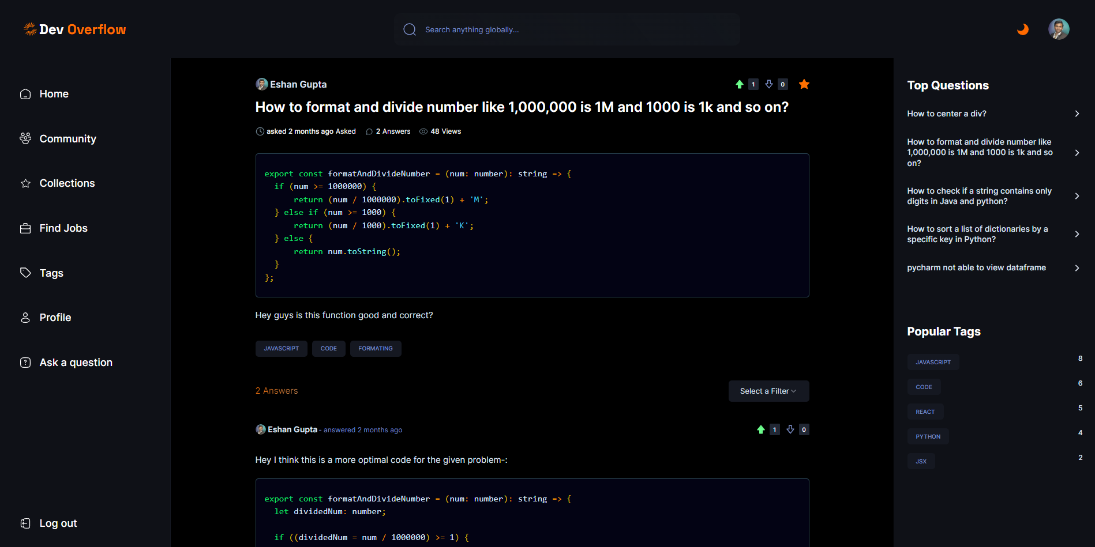

Fig 6.5 View Question and Answer the question Page

[4] Community Page

This page is used for viewing all the current users of the website, different filters like most active user, oldest user and new user can be used. Local search functionality can also be used to search user by his/her name.

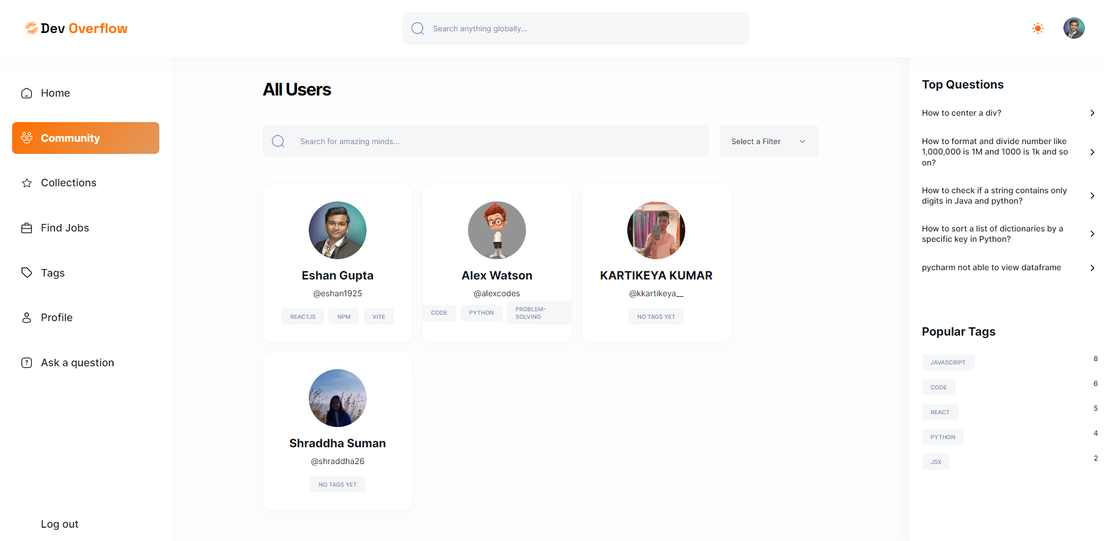

Fig 6.6 Community Page

[5] Collections Page

This page can be used for viewing the saved questions by a user. Filters and local search works here as well.

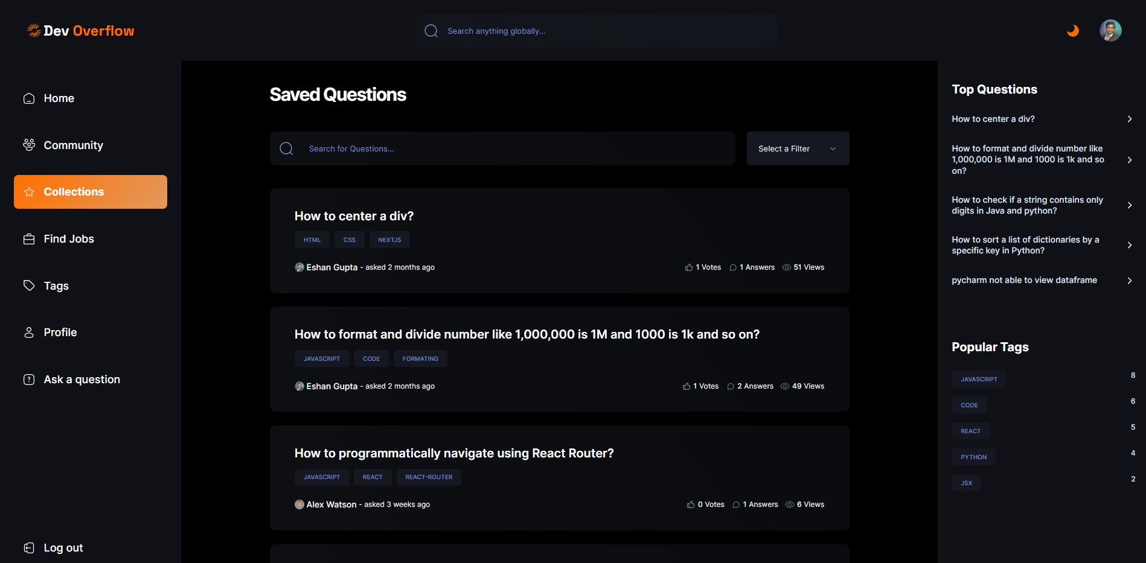

Fig 6.7 Collections Page

[6] Jobs Page

This is an additional feature of the website where a user can come and look for new job openings, these jobs are fetched from RapidAPI.

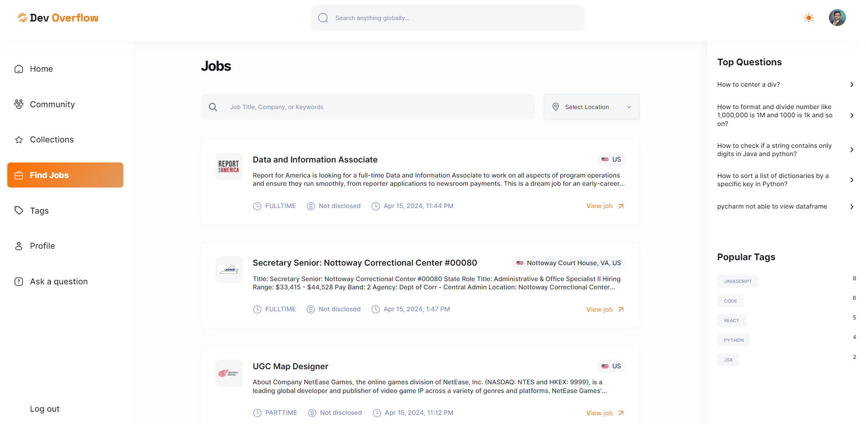

Fig 6.8 Find Jobs Page

[7] Tags Page

This page can be used for viewing all of the tags that are used in the website while creating questions. The filters and local search work here as well.

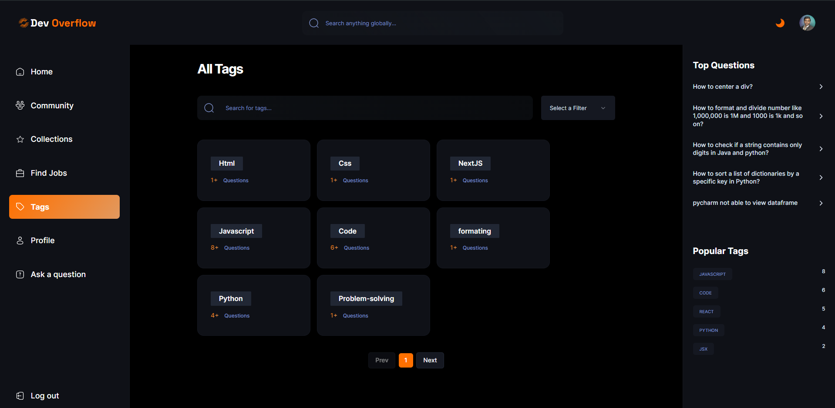

Fig 6.9 Tags Page

[8] Profile Page

This page is used for viewing a user profile, it shows all the details of the user such as how many badges a user has, what is his/her reputation, number of questions and answers a user has given.

Reputation and badges are calculated using number of views and interactions from a user.

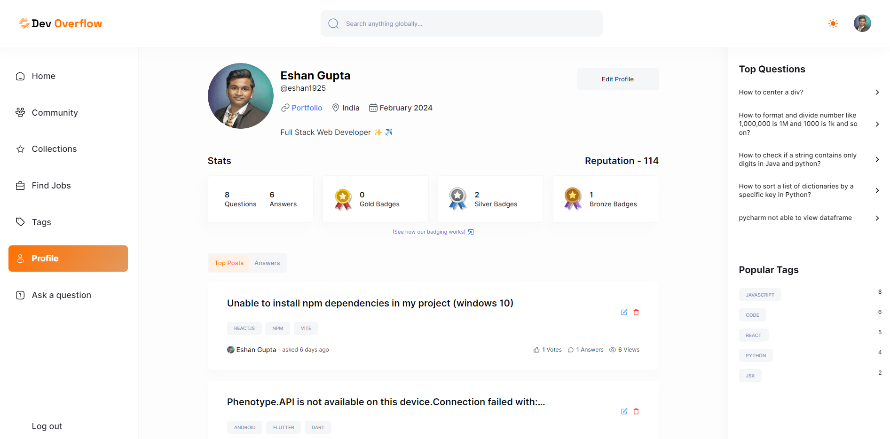

Fig 6.10 Profile Page

[9] Ask a Question Page

This page is used for creating a question, the user has to give a title to the question and a description, with this he also has to add 3 tags related to the question and then he/she can post the question to be visible at all the questions section.

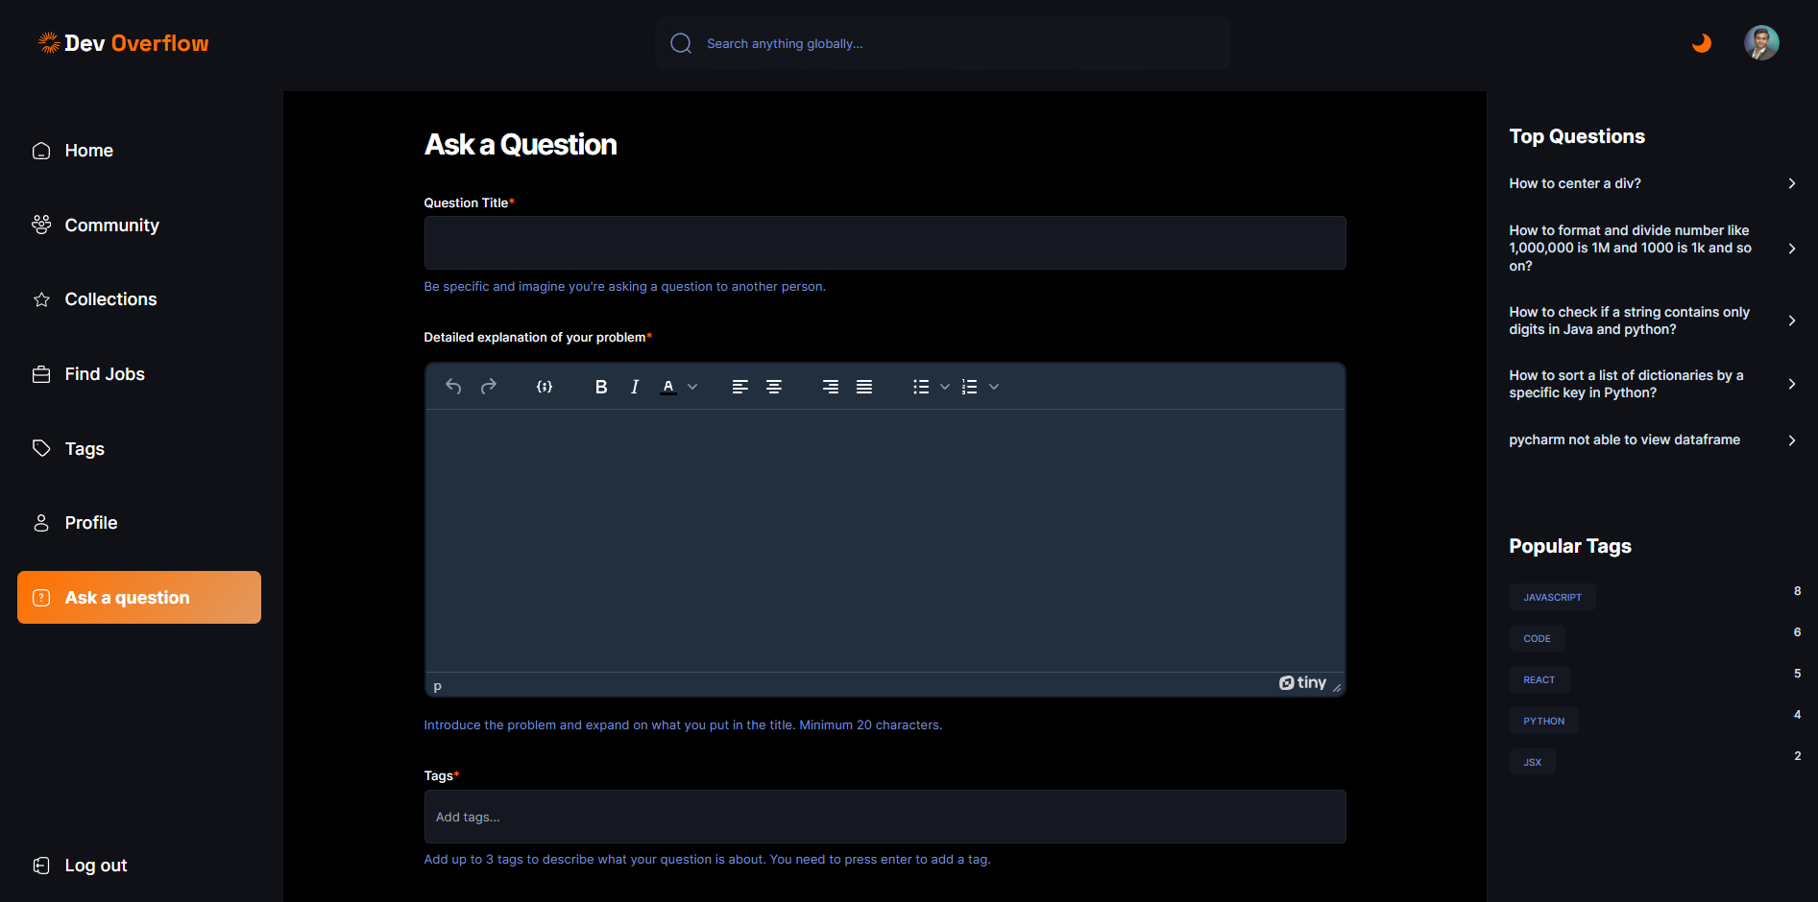

Fig 6.11 Ask a Question Page

[10] Edit Profile Page

This is the edit profile page the user can edit his/her profile here, like name, location, portfolio etc.

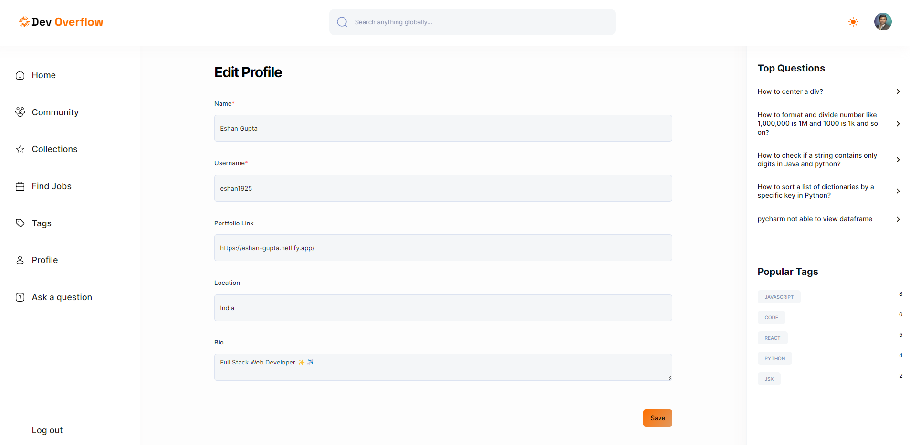

Figure 6.12 Edit Profile Page

Now let’s discuss about the MongoDB Schemas or tables that we have used in our project-:

1. **User Schema-:**

Tab 6.1 User Schema

|  |  |  |
| --- | --- | --- |
| **Field** | **Field Type** | **Required** |
| clerkId | String | Yes |
| Name | String | Yes |
| Username | String (Unique) | Yes |
| Email | String (Unique) | Yes |
| Password | String | No |
| Bio | String | No |
| Picture | String | Yes |
| Location | String | No |
| portfolioWebsite | String | No |
| Reputation | Number (Default:0) | No |
| Saved | Array of Schema.Types.ObjectId (ref: 'Question') | No |

This was the schema used for creating a user and storing his information.

1. **Question Schema-:**

Tab 6.2 Question Schema

|  |  |  |
| --- | --- | --- |
| Field | Field Type | Required |
| Title | String | Yes |
| Content | String | Yes |
| Tags | Array of Schema.Types.ObjectId (ref: "Tag") | No |
| Views | Number (Default: 0) | No |
| Upvotes | Array of Schema.Types.ObjectId (ref: "User") | No |
| Downvotes | Array of Schema.Types.ObjectId (ref: "User") | No |
| Author | Schema.Types.ObjectId (ref: "User") | No |
| Answers | Array of Schema.Types.ObjectId (ref: "User") | No |
| createdAt | Date (Default: Date.now) | No |

This was the schema used for creating a question and storing all the information related to it.

1. **Tag Schema-:**

Tab 6.3 Tag Schema

|  |  |  |
| --- | --- | --- |
| Field | Field Type | Required |
| Name | String (unique) | Yes |
| Description | String | Yes |
| Questions | Array of Schema.Types.ObjectId (ref: 'Question') | No |
| followers | Array of Schema.Types.ObjectId (ref: 'User') | No |
| createdAt | Date (Default: Date.now) | No |

This was the schema used for creating a tag and storing all the information related to it.

1. **Answer Schema-:**

Tab 6.4 Answer Schema

|  |  |  |
| --- | --- | --- |
| **Field** | **Field Type** | **Required** |
| Author | Schema.Types.ObjectId (ref: "User") | Yes |
| Question | Schema.Types.ObjectId (ref: "Question") | Yes |
| Content | String | Yes |
| Upvotes | Array of Schema.Types.ObjectId (ref: "User") | No |
| Downvotes | Array of Schema.Types.ObjectId (ref: "User") | No |
| CreatedAt | Date (default: Date.now) | Np |

This was the schema used for creating an answer and storing it.

1. **Interaction Schema-:**

Tab 6.5 Interaction Schema

|  |  |  |
| --- | --- | --- |
| **Field** | **Field Type** | **Required** |
| User | Schema.Types.ObjectId (ref: "User") | Yes |
| Action | String | Yes |
| question | Schema.Types.ObjectId (ref: "Question") | No |
| Answer | Schema.Types.ObjectId (ref: "Answer") | No |
| Tags | Array of Schema.Types.ObjectId (ref: "Tag") | No |
| CreatedAt | Date (default: Date.now) | No |

This was the schema used for recording an interaction and storing it in the database. This is also one of the important schemas as it used majorly in writing the recommendation algorithm and also for calculating the reputation.

The entire project code and the commit history for this project can be found at the GitHub link provided.

Link -: <https://github.com/eshan1925/stackoverflow_nextjs13>

The live and hosted version of this website can be visited using the below provided link.

Link-: <https://devoverflow-eshan.vercel.app/>

1. **Cost Analysis/ Result and Discussion**

The development of DevOverFlow, an AI-powered Q&A platform, has yielded promising results while maintaining a cost-effective approach. By leveraging open-source technologies such as NextJS, React, and MongoDB, the project has significantly reduced the overhead costs associated with proprietary software licenses.

One of the primary expenses incurred was the integration of OpenAI's text generation API, which provided the AI capabilities central to the platform's functionality. The expense can be recorded as a n expense of 5.90$. However, the long-term benefits of delivering accurate and instantaneous answers to users outweigh the initial investment in this cutting-edge technology.

The use of Tailwind CSS and responsive design principles has ensured that DevOverFlow is accessible across a wide range of devices, maximizing its potential user base without incurring additional costs for developing separate mobile applications.

The project's focus on performance optimization through techniques like server-side rendering (SSR) and incremental static regeneration (ISR) has resulted in a seamless user experience while minimizing infrastructure costs associated with hosting and maintaining the application.

Overall, a period of 4 months or 1 semester was utilised for building this project, and I had a chance to learn about different technologies associated with the project like NextJS, MongoDB, Tailwind-CSS and using different external libraries in the project.

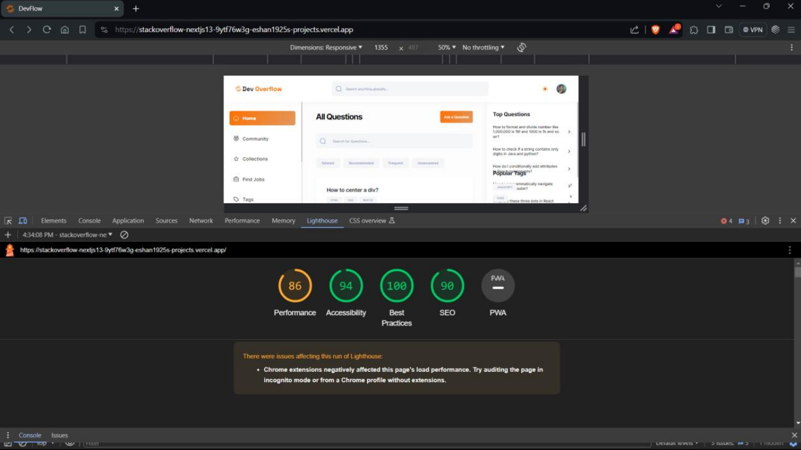

Fig 7.1 Performance Metrics

Now talking about the results obtained on performing the most used test, Lighthouse, DevOverFlow's performance is exceptional. The website scores an impressive 86 in performance, ensuring fast load times and a smooth user experience. Its accessibility score of 94 demonstrates an inclusive design catering to users with disabilities. Adherence to best practices earns a perfect 100, reflecting clean, efficient code. Furthermore, a strong SEO score of 90 indicates excellent search engine optimization, improving visibility and organic traffic. These outstanding Lighthouse results solidify DevOverFlow as a high-performing, accessible, and well-optimized web application, providing a seamless experience for all users.

Overall, the development of DevOverFlow has demonstrated the feasibility of creating a feature-rich, AI-driven web application within reasonable budgetary constraints. The strategic selection of cost-effective technologies, combined with a focus on performance and scalability, has laid the foundation for a sustainable and financially viable platform that can continuously evolve to meet the ever-changing needs of its users.

1. **Summary**

DevOverFlow is an ambitious capstone project that aims to create a sophisticated Question and Answer (Q&A) platform, integrating the functionalities of StackOverflow with innovative features. The primary distinguishing factor is the implementation of AI-powered text generation, facilitated by OpenAI technology, to provide users with instant and accurate answers.

The project leverages cutting-edge technologies, including NextJS version 13.5 as the core framework, MongoDB as the database, and Tailwind CSS for the presentation layer. TypeScript is the language of choice, ensuring robust and maintainable code, with strategic use of React. The architecture is grounded in NextJS fundamentals, encompassing client-server dynamics, runtime versus build time considerations, and versatile rendering strategies like SSR, ISR, SSG, and CSR.

The platform promotes user-friendly interactions by allowing Markdown input for questions and ensuring full responsiveness across diverse devices. Users can pose questions, receiving AI-generated answers alongside community responses. Active participation earns users' badges and reputation points, contributing to an incentivized and dynamic knowledge-sharing ecosystem. In summary, DevOverFlow aspires to redefine Q&A platforms by combining AI innovation with a rich feature set for an unparalleled user experience.

The design of DevOverFlow has been entirely conceived in Figma, offering a cohesive and visually appealing user interface available in both light and dark themes. The project adheres to industry-standard coding practices, design guidelines, and accessibility standards to deliver a high-quality and inclusive platform.

In summary, DevOverFlow is an ambitious capstone project that aims to redefine the Q&A landscape by integrating cutting-edge AI technology, a rich feature set, and a user-centric design approach. By addressing the shortcomings of existing platforms and providing an unparalleled user experience, DevOverFlow aspires to become a leading Q&A platform that fosters dynamic knowledge sharing and collaboration.

1. **References**

[1] Krutika Patil, "NextJs File-Based Routing - A Review," Published in International Journal of Trend in Scientific Research and Development (ijtsrd), ISSN: 2456-6470, Volume-7 | Issue-4, August 2023.

[2] Sasikumar, S., Prabha, S., and Mohan, Chandra, "Improving Performance Of Next.Js App And Testing It While Building A Badminton Based Web App," Proceedings of the International Conference on Innovative Computing & Communication (ICICC) 2022, May 27, 2022.

[3] Mohammad Fariz Syah Lazuardy and Dyah Anggraini, "Modern Front End Web Architectures with React.Js and Next.Js," International Research Journal of Advanced Engineering and Science, Volume 7, Issue 1, pp. 132-141, 2022.

[4] Saptarshi Bhattacharyya and Asoke Nath, "Application of TypeScript Language: A Brief Overview," International Journal of Innovative Research in Computer and Communication Engineering, 2007.

[5] Bierman, G., Abadi, M., Torgersen, M., "Understanding TypeScript," In: Jones, R. (eds) ECOOP 2014 – Object-Oriented Programming. ECOOP 2014. Lecture Notes in Computer Science, vol 8586. Springer, Berlin, Heidelberg, 2014.

[6] Krishnan, Hema, Elayidom, M.Sudheep, and Santhanakrishnan, T., "MongoDB – a comparison with NoSQL databases," International Journal of Scientific and Engineering Research, Vol. 7, pp. 1035-1037, 2016.

[7] Kavya S., "A study on MongoDB Database," Published in IJSRD - International Journal for Scientific Research & Development, Vol. 3, Issue 10, 2015.

[8] Anjali Chauhan, "A Review on Various Aspects of MongoDB Databases," Published in International Journal of Engineering Research & Technology (IJERT), Vol. 8 Issue 05, May-2019.

[9] Pratiksha D Dutonde, Shivani S Mamidwar, Monali Sunil Korvate, Sumangala Bafna, and Prof. Dhiraj D Shirbhate, "Website Development Technologies: A Review," Published in International Journal for Research in Applied Science & Engineering Technology (IJRASET), Volume 10 Issue I, January 2022.

[10] Akhil Krishna and Dr. Padmashree T., "A Survey on Current Technologies for Web Development," Published in International Journal of Engineering Research & Technology (IJERT), Vol. 9 Issue 06, June-2020.

[11] Xing, Yongkang, Huang, JiaPeng, and Lai, YongYao, "Research and Analysis of the Front-end Frameworks and Libraries in E-Business Development," Published in 2019 11th International Conference ICCAE.

[12] Arnav Awasthi, Shubham More, and Warren Viegas, "Research and Analysis of the Front-end Frameworks and Libraries in Web Development," Published in International Journal for Research in Applied Science & Engineering Technology (IJRASET), Volume 10 Issue IV, April 2022.

**APPENDIX A**

* **Setting up the project-:**

For setting up this project locally follow the steps given below-:

Step1 – Open this link (<https://github.com/eshan1925/stackoverflow_nextjs13>) in your browser.

Step2 – Now copy this link to your console.

Step3 - Open a terminal or command prompt on your local machine.

Step4 - Navigate to the directory where you want to clone the repository using the “cd” command.

Step5 - Clone the repository using the following command:

“git clone https://github.com/eshan1925/stackoverflow_nextjs13.git”

Step6 - Change the current working directory to the cloned repository folder:

“cd stackoverflow_nextjs13”  
Step7 – Type the following command to open VS Code:

“code .”

Step8 – Type the following command to install all the node modules:

“npm i”

Step9 – Setup the .env.local using the .env.global template given in the repository.

Step10 – Type the following command in the terminal:

“npm run dev”

You have successfully cloned the repo and now your website should be visible on the address-: http://localhost:3000

* **Deployment Instructions-:**

For deploying this project, you need to raise a pull request to the main branch of the repository and get you code merged to it, once that happens you will be able to see the changes on the live website.

* **Future Scopes-:**

• **Blog Section:** Implementing a dedicated blog section within the platform, allowing users to write, publish, and share their thoughts, insights, and experiences related to various topics. This feature would foster a vibrant community of knowledge-sharing and encourage user-generated content.

• **Open to All Users:** After a successful beta phase, opening the website to a wider audience, transitioning from a closed or invite-only system to a publicly accessible platform. This move would enable a larger user base to benefit from the advanced Q&A functionalities, AI-powered text generation, and the wealth of knowledge available on the platform.

**• Enhanced User Profiles:** Expanding user profiles to include additional customization options, such as personalized cover photos, bios, and the ability to showcase their expertise through badges, certifications, or portfolio sections.

**• Gamification:** Introducing gamification elements to incentivize user engagement and participation. This could include leaderboards, achievement systems, and rewards for consistent contributions, fostering a competitive and engaging environment.

**• Mobile Applications:** Developing native mobile applications for iOS and Android platforms, ensuring a seamless experience for users on-the-go and enabling push notifications, offline access, and other mobile-specific features.

By implementing these future scopes, the project aims to continuously evolve, offering a more comprehensive and engaging experience for its users, while solidifying its position as a leading Q&A platform in the industry.

* **3rd Part Libraries-:**Various 3rd party libraries were used for implementation of the project and some of them are as follows-:
* Clerk – This was used for the purpose of Authentication of the users.
* TinyMCE – This was used for incorporating the feature of the editor (ask a question)
* ShadCN UI – This was used for using a lot of predefined UI Components.
* OpenAI API – This library was used for enabling the users with Generate AI Answer feature.